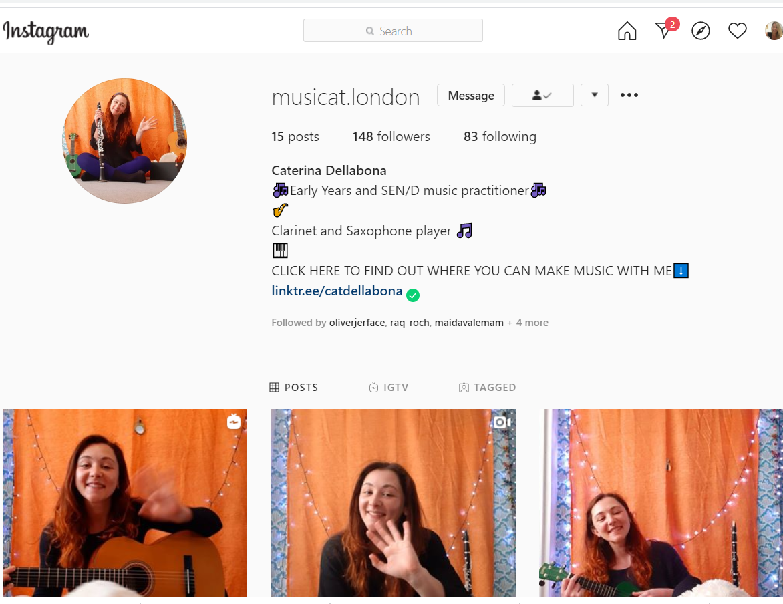
The lovely and talented Miss Dellabona has an Instagram page dedicated to music for children. Explore her page and you can even do music with Miss Dellabona

