Year 5 and 6 Local Community work with Kindred Studios

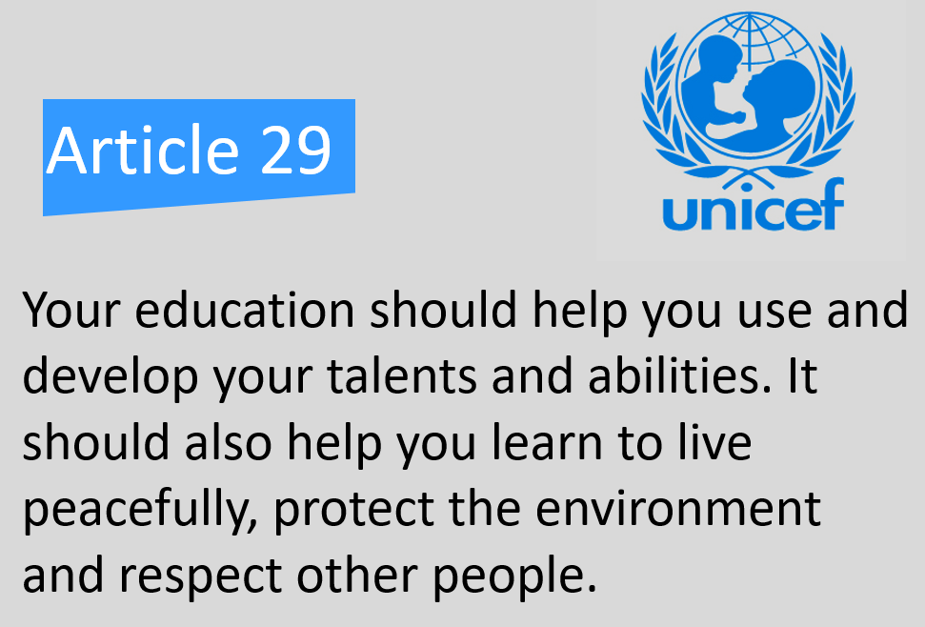

Year 5 and 6 were fortunate to have artist- led workshops at Kindred Studios which involved getting the studios decorated in order to open up to the local community. They were helping the local community and also learnt many new skills.



