St Peter’s Year 2 Overview
Year 2 | Autumn 1 | Autumn 2 |  | Spring 1 | Spring 2 |  | Summer 1 | Summer 2
English | 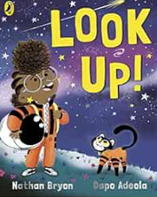  Look up! By Nathan Bryon  Outcome:  Recount write a diary entry  Curriculum links Celebrating Black lives | 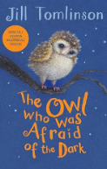  The Owl who was afraid of the dark by Jill Tomlinson (and Chapter Version)  Outcome:  Non-fiction: write a report  Curriculum links Geography – continents and oceans History – gunpowder plot |  | 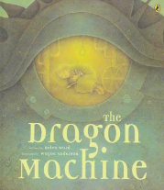  The Dragon Machine by Helen Ward, How to Train Your Dragon (2010 film), The Dragonsitter by Josh Lacey  Outcome  Fiction: write a story with an adventure focus  Curriculum links Geography – bird’s eye view, maps and globes, four countries of the UK | 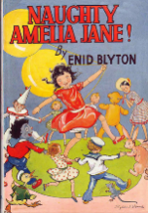  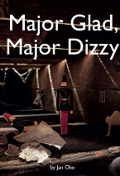  Major Glad, Major Dizzy by Jan Oke, Naughty Amelia Jane by Enid Blyton  Outcome  Recount: a recount of events from character’s point of view  Curriculum links History – arc of time/significant events - Victorians, WW2 |  | 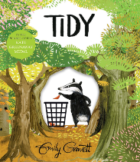  Tidy by Emily Gravett  Outcome  Persuasion: write a letter in role  Curriculum links Geography/science – protecting the environment | 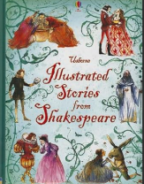  Usborne Illustrated Stories from Shakespeare (The Tempest) Adapted by Rosie Dickens  Outcome  Fiction: retell an abridged and adapted version  Curriculum links Speaking and listening focus – Shakespeare
Poetry | 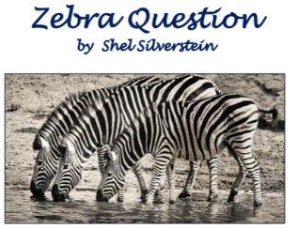 | 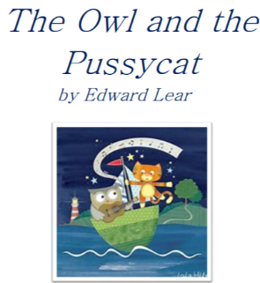 |  | 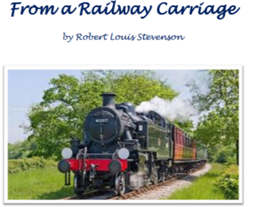 | 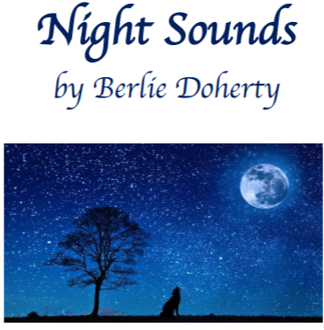 |  | 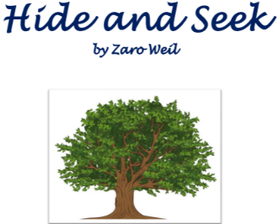 | 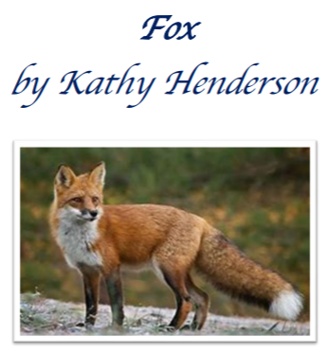
Maths | Place Value  Addition and Subtraction  Shape |  |  | Money  Multiplication and Division | Length and Height  Mass, capacity and temperature |  | Fractions  Time | Statistics  Position and Direction
Science | Habitats | Microhabitats |  | Use of everyday materials | Life cycles and health |  | Plant growth | Plant-based materials
RE | Why did Jesus teach the Lord’s prayer as the way to pray? | Who Is the Saint of Our School?  Where is the light of Christmas? |  | Why are they having a party? | How do the symbols of Easter help us understand the meaning of Easter for Christians? |  | How do the five pillars of Islam help a Muslim to show their commitment to God? | Why do Christians make and keep promises?
Computing | Computing systems and networks – IT around us | Creating media – Digital photography |  | Programming A – Robot algorithms | Data and information – Pictograms |  | Creating media – Making music | Programming B – An introduction to quizzes
Geography/  History | Geography  Would you prefer to live in a hot or cold place? | History  The Gun Powder Plot |  | History  Famous People: Explorers Nurses | Geography  Why is our world wonderful? |  | History  Famous Queens | Geography  What is it like to live by the coast?
PSHE | Families and relationships  Health and wellbeing |  |  | Safety and the changing body  Citizenship |  |  | Economic wellbeing  Transitions
PE | Gymnastics  Multi Skills through Games | Multi Skills (Movement)  Ball Skills |  | Dance  Healthy Lifestyles and Fitness | Multi Skills (Ball Skills – football, basketball etc)  Multi Skills (Using Space) |  | Athletics | Tag Rugby  Dodgeball
Music | Ongoing skills Unit A:  Music literacy, song and tuned and untuned percussion instruments
Music | 2a: ‘Taking off’  Exploring pitch |  | 2b: ‘What’s the score?’  Exploring instruments & symbols |  |  | 2c: ‘Rain, rain, go away’  Exploring timbre, tempo & dynamics
Art/DT | Art & Design  Craft and Design: Map it Out | DT  Mechanisms: Making a Monster |  | Art & Design  Drawing: Tell a Story | DT  Textiles: Pouches |  | Art & Design  Painting and Mixed Media: Life in Colour | DT  Structures: Making Baby Bear’s Chair

