Skills
1785 ÷ 13 MDCXL 32 x 7 = 368 - _____

Use and Apply
A factory produces paint in three colours: red, blue and yellow.  They produce five cans of yellow paint and three cans of blue paint for every red can.  Today, they have produced 567 cans of paint.  How many cans of blue paint was produced? | 8 children achieved the following spelling scores:  12, 16, 19, 19, 18, 17, 13, 6  - What is the mean spelling score?  - What is the median spelling score?  - What is the mode spelling score?  - What is the range in spelling scores?
Write down the fractions that the arrows are pointing to.  If possible, give your answer as a mixed fraction.  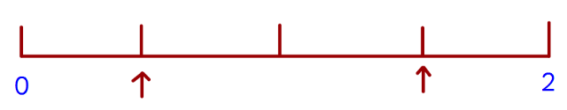 | 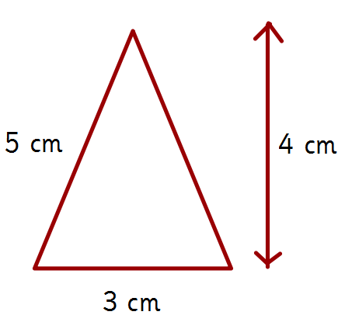  Draw a rectangle that  has an area six times  the size of the triangle.
A giraffe weighs 6 times more than a zebra.  A giraffe and zebra’s combined weight is 1792 kg.  What is the weight of a giraffe? |   Stefan’s watch shows five minutes past nine.  The watch is thirteen minutes fast.  What is the correct time?
Maria bakes cakes and sells them in bags.  She uses this formula to work out how much to charge for one bag of cakes.  Cost = number of cakes x 20p + 25p for bag  - How much will a bag of 12 cakes cost?  - Melissa pays £2.05 for cakes. How many cakes did she buy? | What number is halfway between 1.6 and 2.5?
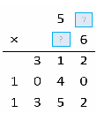
What are the two missing
digits to make this long
multiplication?
What is the highest common factor of 24 and 64?  A shaded isosceles triangle is drawn inside a rectangle.  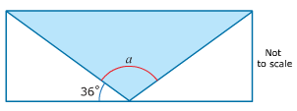  What is the size of angle a? | I think of a number. I divide it by two, add six and then subtract 8. My answer is 4.5.  What number did I begin with?
 | Large pizzas cost £7.75 each. Small pizzas cost £4.50 each. Five children together buy one large pizza and three small pizzas. They share the cost equally. How much does each child pay?
One gram of gold costs £24.74.  What is the cost of half a kilogram of gold? | Seven children measure their heights.  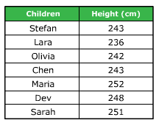  What is the mean height of the children?
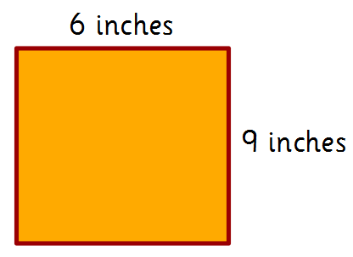
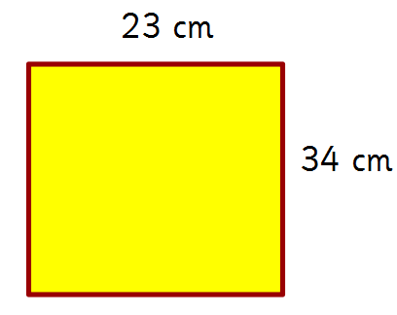
Ahmed has two sheets of paper:

How much larger, in cm², is the area of the yellow sheet of paper?
1 inch = 2.5 cm
 | 

