Writing
Activity:
Write a descriptive paragraph about the picture from King Midas’ labyrinth below, using some of the vocabulary on the picture or from the word bank below.
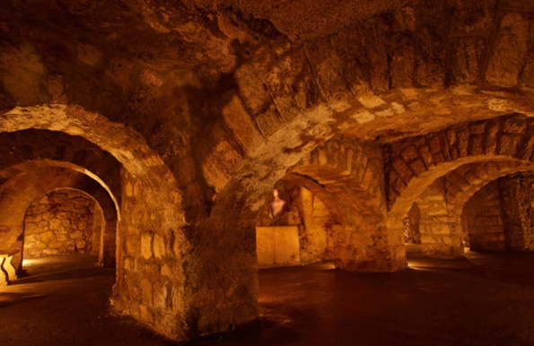
Word bank:
scary dark twisting grotty
eerie dingy turning grimy
creepy dim tangled grubby
sinister gloomy filthy befouled
sandy floor
dim lights
stone ceiling
arch
pillar

Words of the same colour have the same or similar meanings.
Write in present tense.
Think about what you can see, hear, smell, taste, and touch in the dark corridors of the labyrinth.
Activity two:
Think about how you would feel if you were stuck down here. Draw a large outline of a body, filling an A4 sheet, and fill it with emotions that you may feel.
Challenge: Can you show not tell? Write physical signs of these emotions outside of the body eg if you have written frightened, your character could be sweating.

Activity three:
Improve the piece of writing. Can you correct all of the mistakes in this model and improve it further?
dear diary,
i have been stuck down here for 43 days in this __________________ place. King midas said when he threw me here that id never escape and now I think he was rite. I haven’t seen another person in weeks – not one who was live anyway. All of these tortuous twisting tangled corridors look exactly the same. I’ll never find my way out all i can here is mice and rats squeaking I think they are following me because they can tell I have sum food left. Not that I have very much. what will happen to me when I’ve run out. I cant even think abowt it.
will I ever see daylight again?
Miss Butland

Activity four:
Plan your diary entry. What will happen to your character? Will they meet another person or see something that they haven’t seen before? Write your plan thinking about what will happen and your character’s reactions to it.
Activity five:
Write a diary entry, or series of diary entries, imagining that you are stuck in King Midas’ cave.

Sentence starters:
I have been…
This morning I saw…
Yesterday I heard…
I thought I saw… but…

