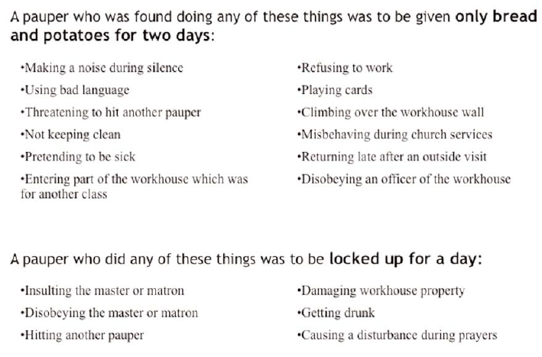
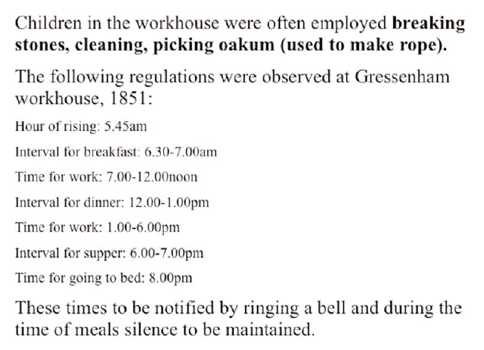
Source B
Source A
Source B
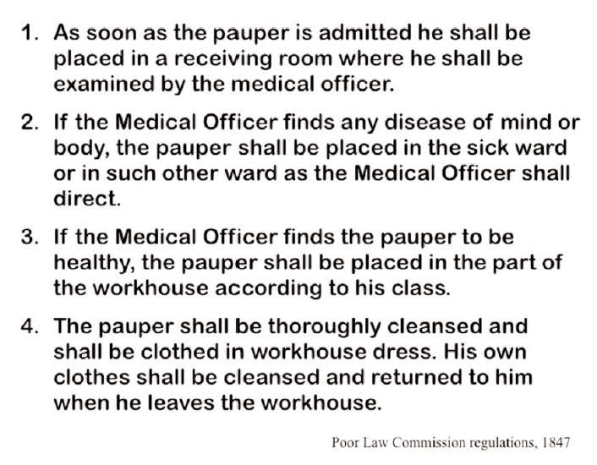
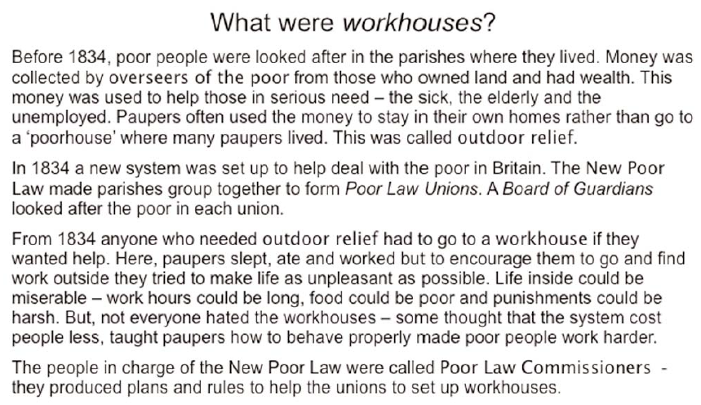
Source C
Source D
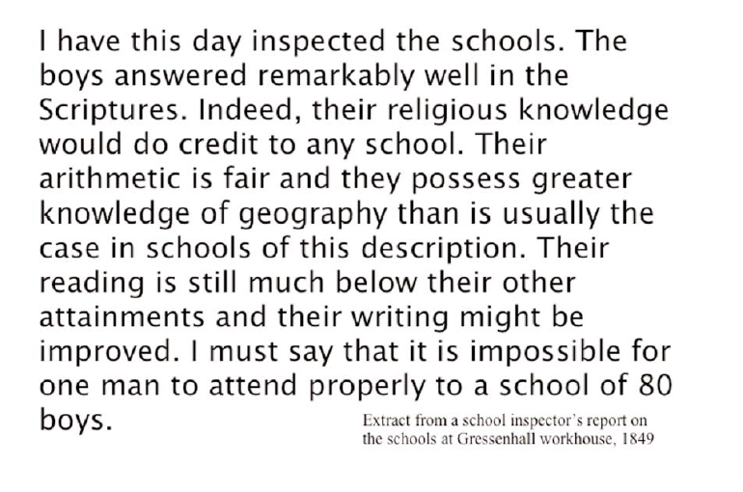
Source E

Source F

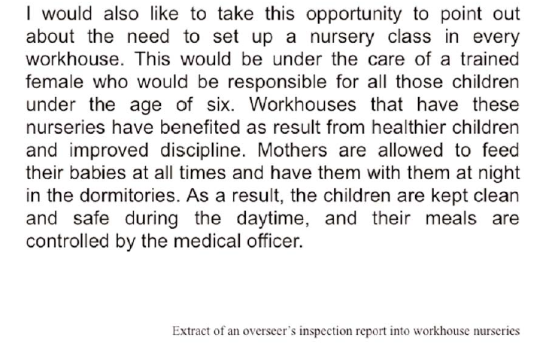

Source G
“The food was served up with pieces of black stuff floating around. On exmination, we discovered it to be rat and mice manure. I called for the chief officer, who said the porridge was good.”
George Lansbury, guardian of Poplar workhouse, of the oatmeal porridge served in 1893.

Source H
“The inmates had not sufficient clothes and many were without boots to their feet. ‘Poverty’s no crime, but here it is treated like crime,’ they used to say.”
Description from Will Crooks, a former inmate of Poplar.

Source I
“9th October: Hannah Hickling spent five hours in solitary confinement for using obscene and profane language and annoying other inmates.
14th November: John Fox and William Crooks had their meat stopped at dinner for fighting.”
Entries in the punishment book for Southwell workhouse in 1864.

