Finding Shapes in Flags!

Pick one of the flags below and investigate the questions:
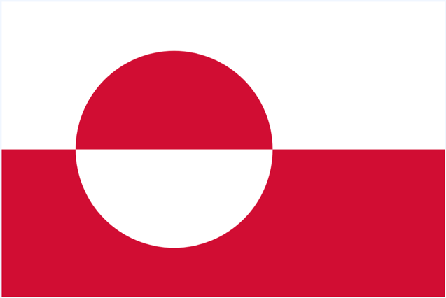
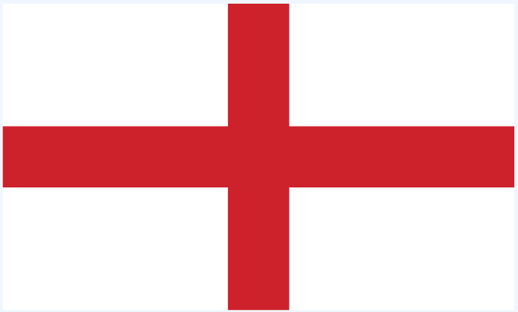

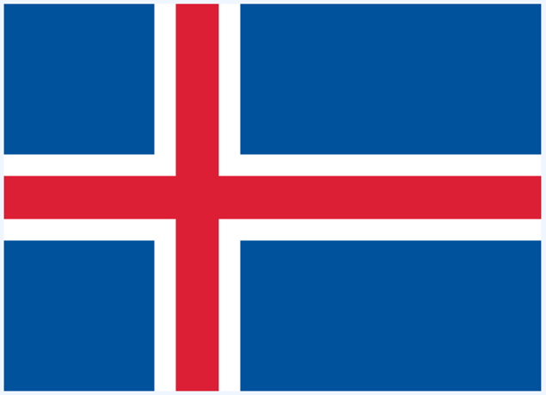
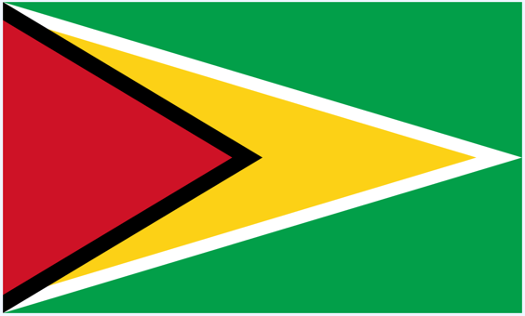


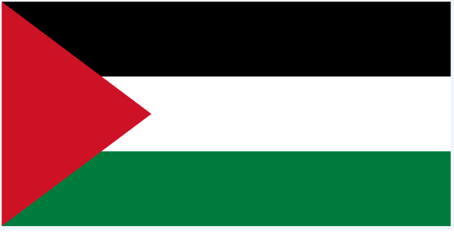

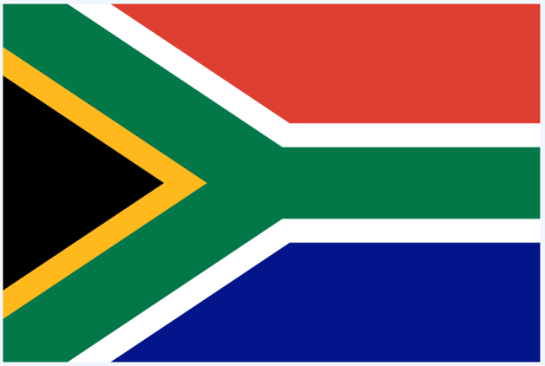
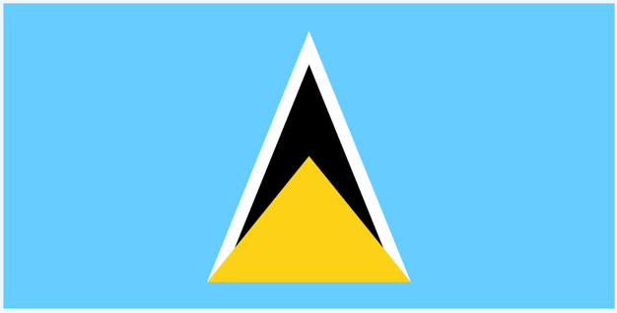

Questions

- What shapes can you see in your chosen flag?

- Does the flag have any lines of symmetry? If yes, how many?

- Can you find any pairs of parallel lines?

- Can you write a list of all the different shapes in the flag?

Challenge

- Have a go at designing your own flag! It should include:
- 1 hexagon
- 2 quadrilateral polygons
- Any type of triangle
- Lots of colours!

