Friday Zoom and English for next week:
What might the snowman be thinking or saying?
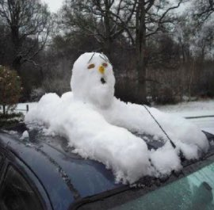

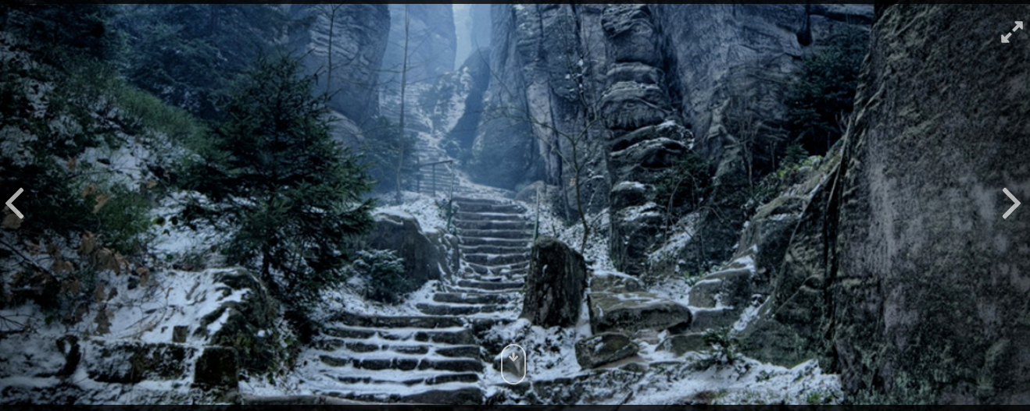

W

Daunting scary intimidating frosty glacial winds colossal towering sky high
The brave explorer looming rugged mountains worn out
Soaring through the clouds

Who is the adventurer in the story? The adventurer in this story is ……….
Can you think of a good name for him/her? A good name for him……….
Why does he/she want to climb High Hrothgar? She
Why are people afraid of the mountain? People are terrified
What do you think awaits him at the top? I think that at the top of the mountain,
At the top of the snowy, white mountain, there is…………
At the top of the frosty mountain, there will be a terrifying cave
Waiting at the top of the snowy mountain, there are
What might the adventurer be carrying with him? I think the adventurer will be carrying…..

Let us analyse my story starter:
The mountain of High Hrothgar had stood proudly for thousands of years, casting a solemn shadow for miles around.
Few dared to venture close to its base, let alone scale its heights, fearing what awaited at the summit. For one brave adventurer, the folk lore surrounding the mysteries of High Hrothgar provided an opportunity just too tempting to resist. Some called him courageous, others foolish, but it mattered not to him now.
Bracing himself against the torrent of icy wind that rushed towards him down the narrow, winding pass, the lone figure prepared himself for the challenge ahead. He took a deep breath, feeling the frozen air rush into his lungs, and took a bold step onto the path to High Hrothgar…

- Can you find an adjective? foolish 4. Can you find personification? 6. Is there alliteration?
- Can you find a pronoun? 5. Are there any new words? 7. A 2 a sentence?
- Can you find an adverb? 8. What do we think torrent means? New word tentatively

Improve some sentences

The adventurer began to walk up the path. It was cold. It was slippery. It was steep. It was snowing.

Daunting scary intimidating frosty glacial winds colossal towering sky high
The brave explorer looming rugged mountains worn out
Soaring through the clouds tentatively a torrent of icy wind
The great adventurer began to slowly to walk up the narrow path
Slowly, the great adventurer
Tentatively,
Worn out and tired the adventurer started
With great trepidation
Hesitantly,
Hands shaking from the cold, the

Work for you to by next Friday:
Describe the mountain path:
Can you use your senses to describe the mountain pass to High Hrothgar?
What can you see/hear/smell/feel/taste?
Think about the following things:
the path wind trees
snow ice cloud
fog the summit voices
stone air fear
danger skin face

Once you have described the path, you can add on the sentences you have improved and carry on writing the story.

https://www.pobble365.com/the-skypath/

https://www.pobble365.com/the-mountain-pass/

