Friday 3rd April 2020

LO: to write a diary entry

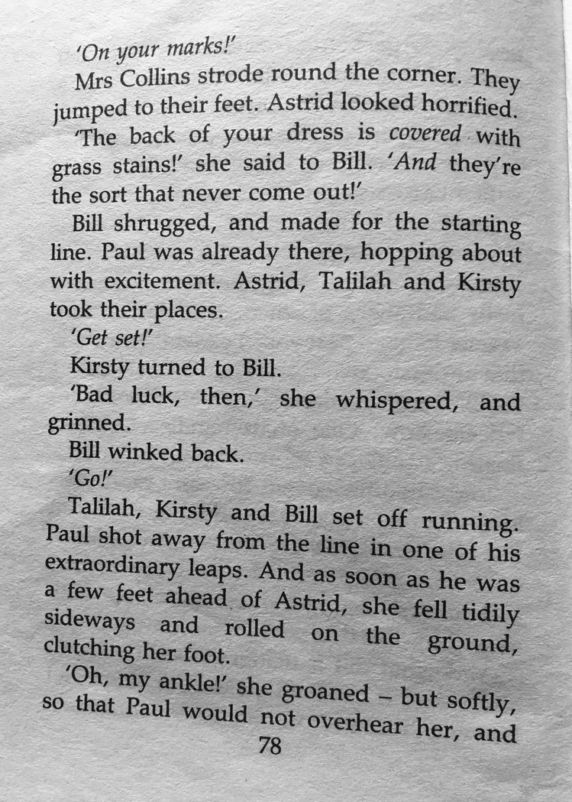
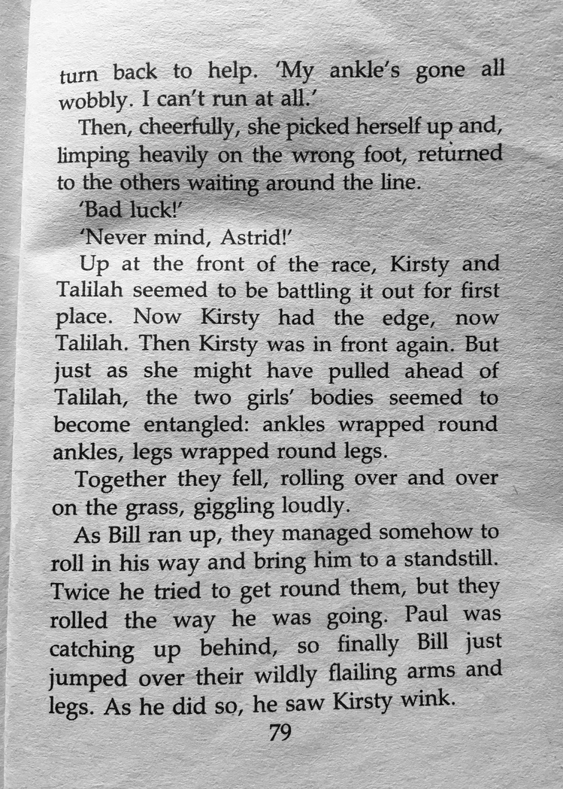
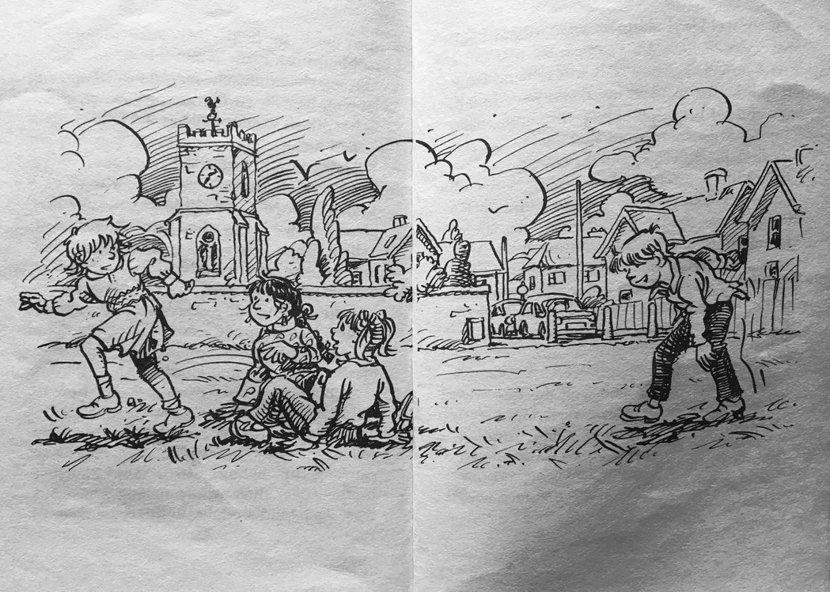
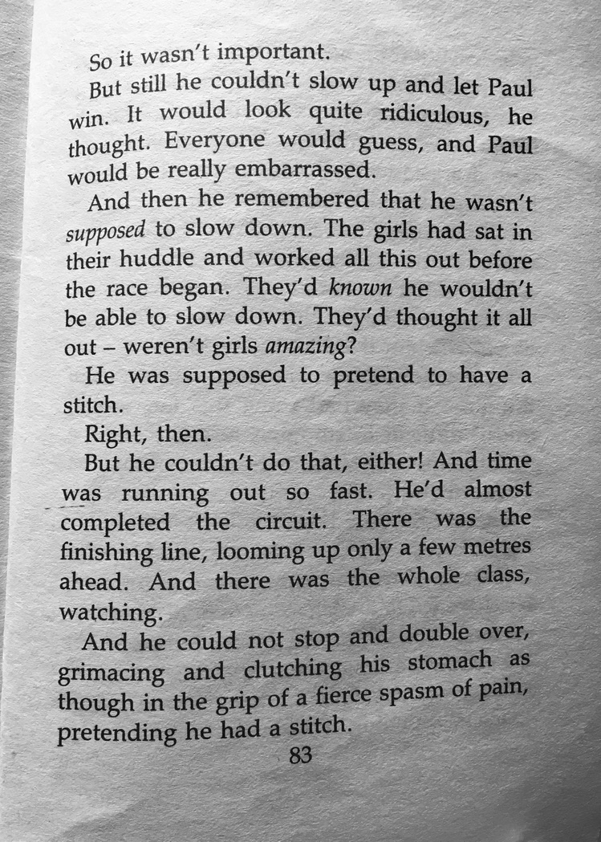
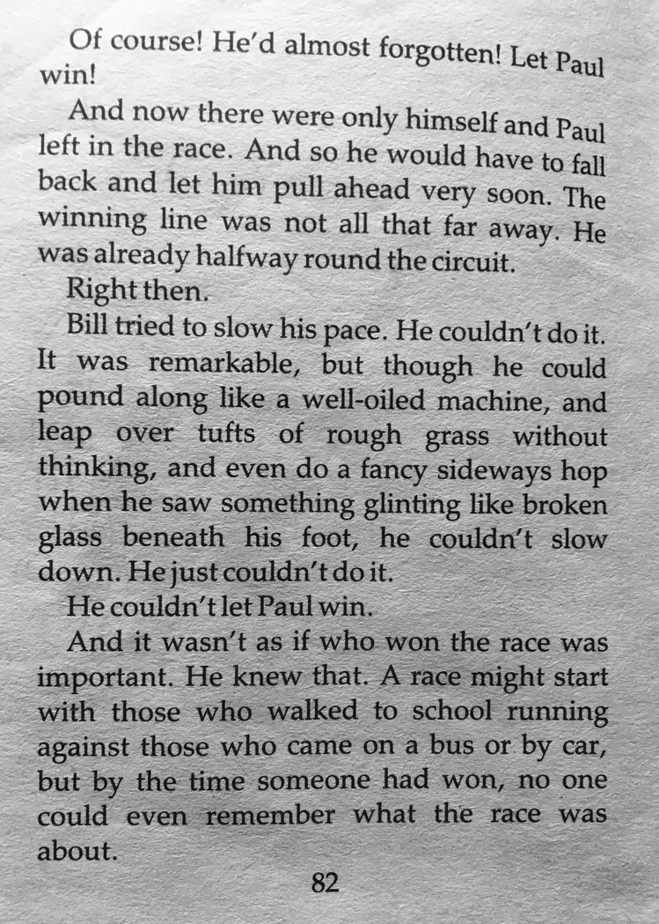
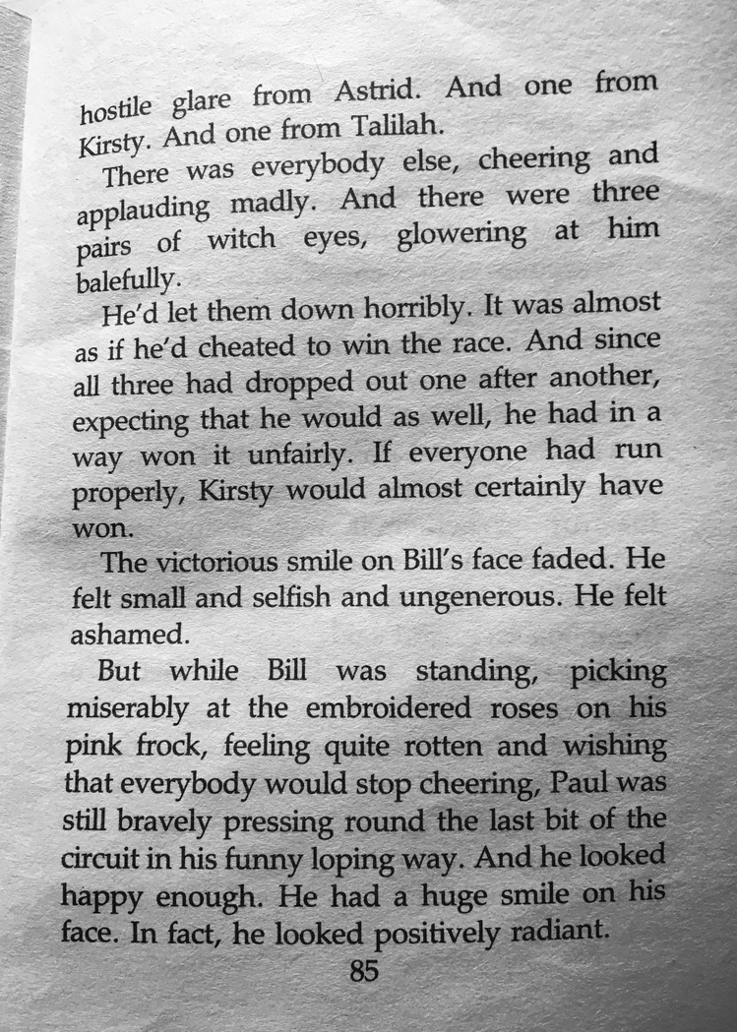
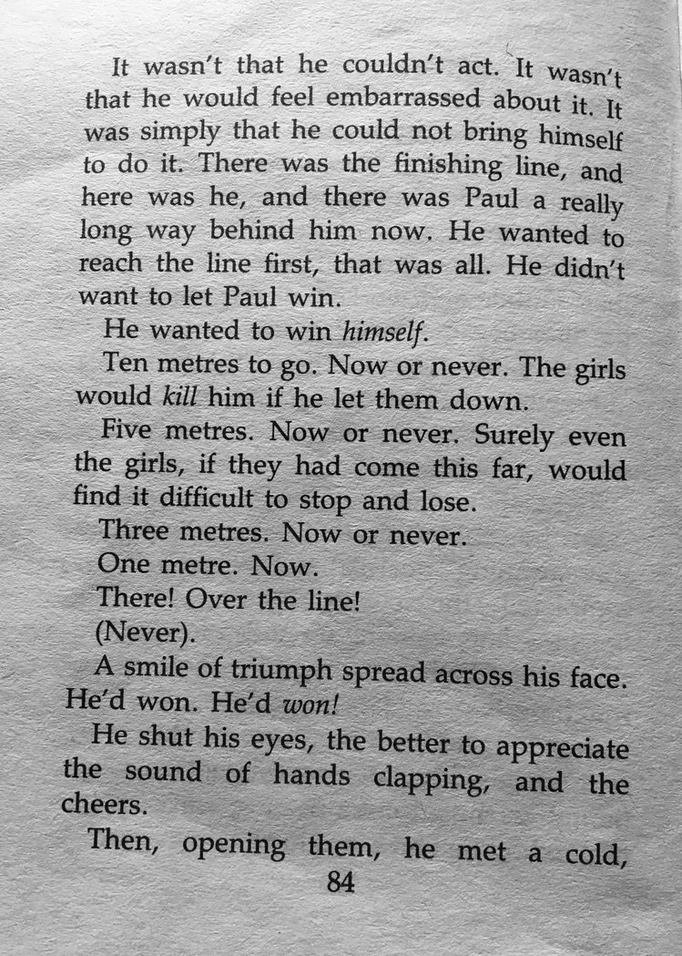

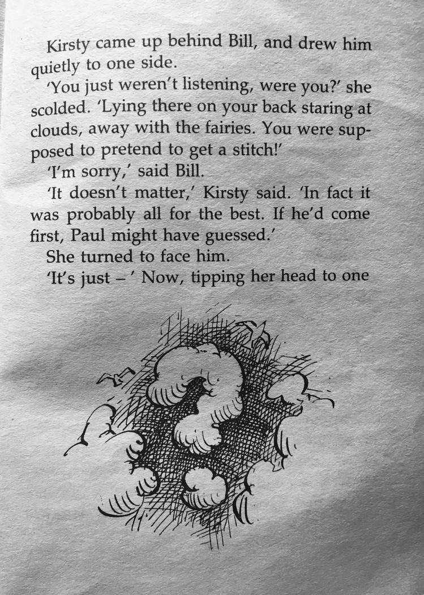
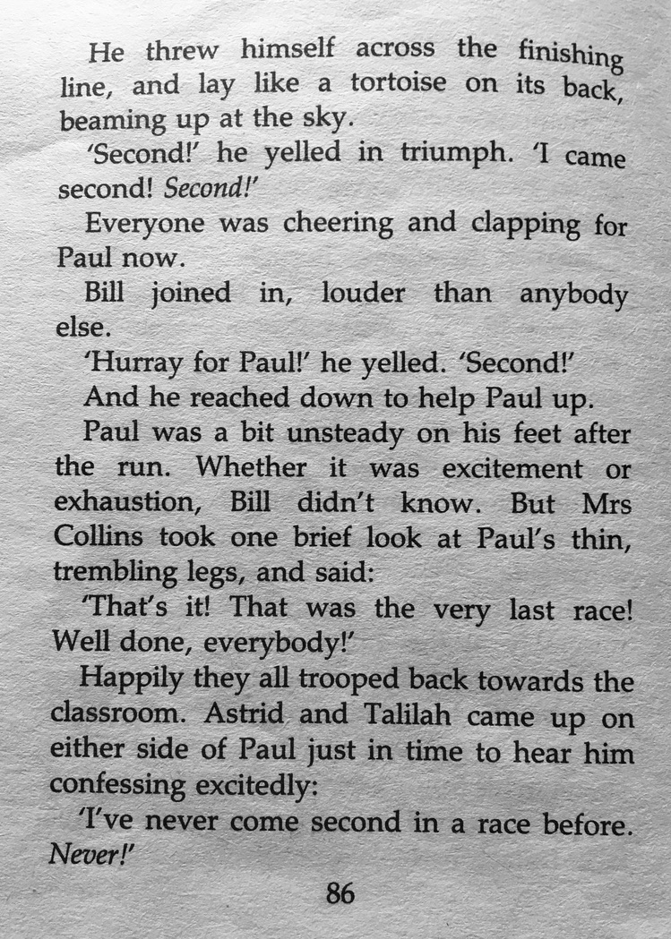

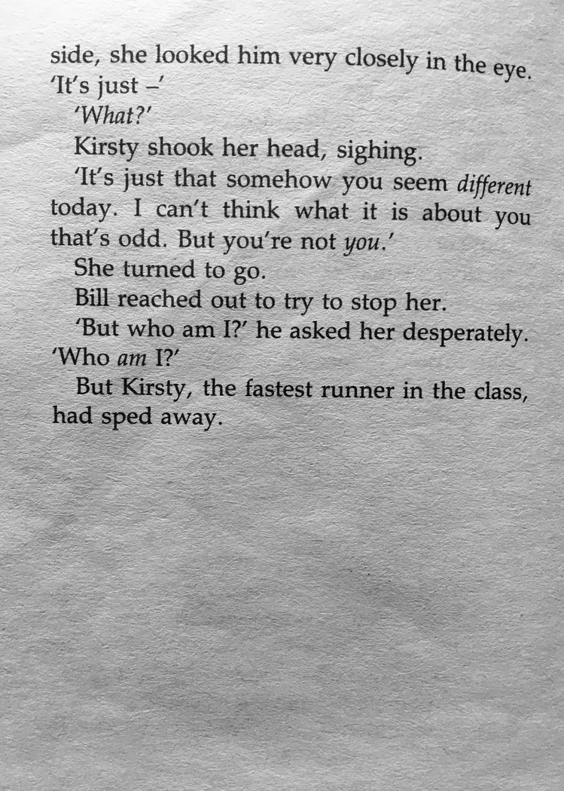
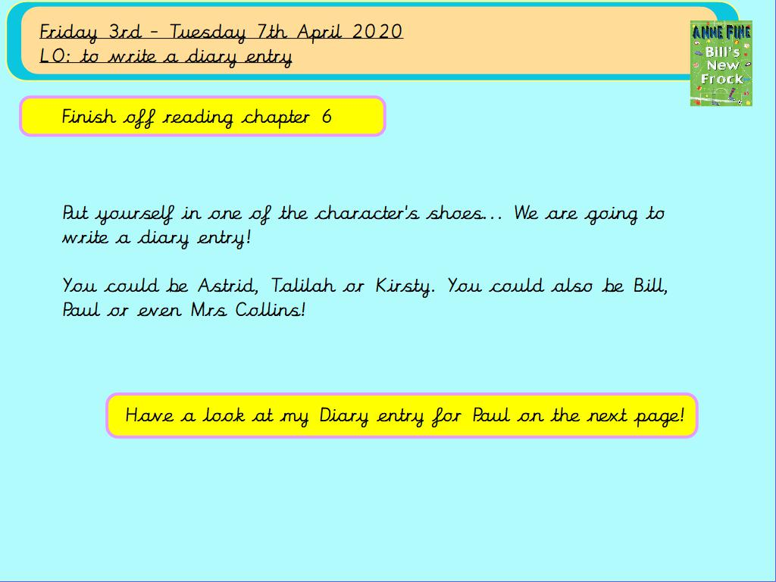
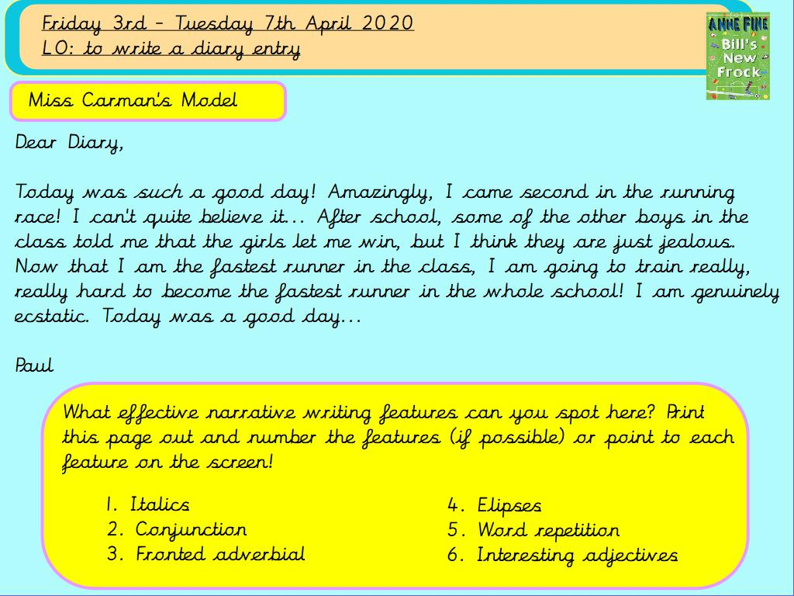
Dear Diary,

Today was such a good day! Amazingly, I came second in the running race! I can’t quite believe it… After school, some of the other boys in the class told me that the girls let me win, but I think they are just jealous. Now that I am the fastest runner in the class, I am going to train really, really hard to become the fastest runner in the whole school! I am genuinely ecstatic. Today was a good day…

Paul

Why not try and improve my diary entry! Do I meet all the ‘How to write a: Diary’ success criteria?


