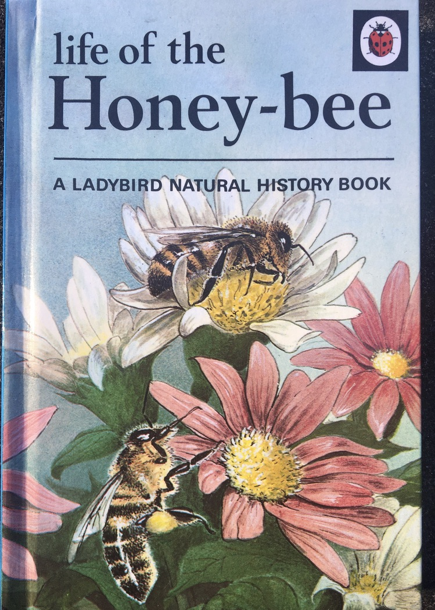

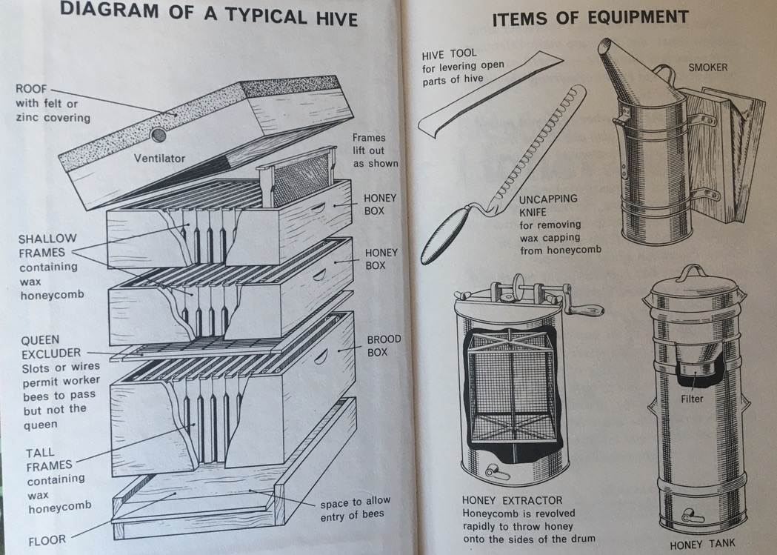

Comprehension Questions

- Why does the roof have a ventilator?

- What other objects are typically made using the material, felt?

- What does the word, ‘excluder’, mean? Try and use a description from the diagram to justify your answer.

- Have you ever seen a beehive before? What do you remember about it?

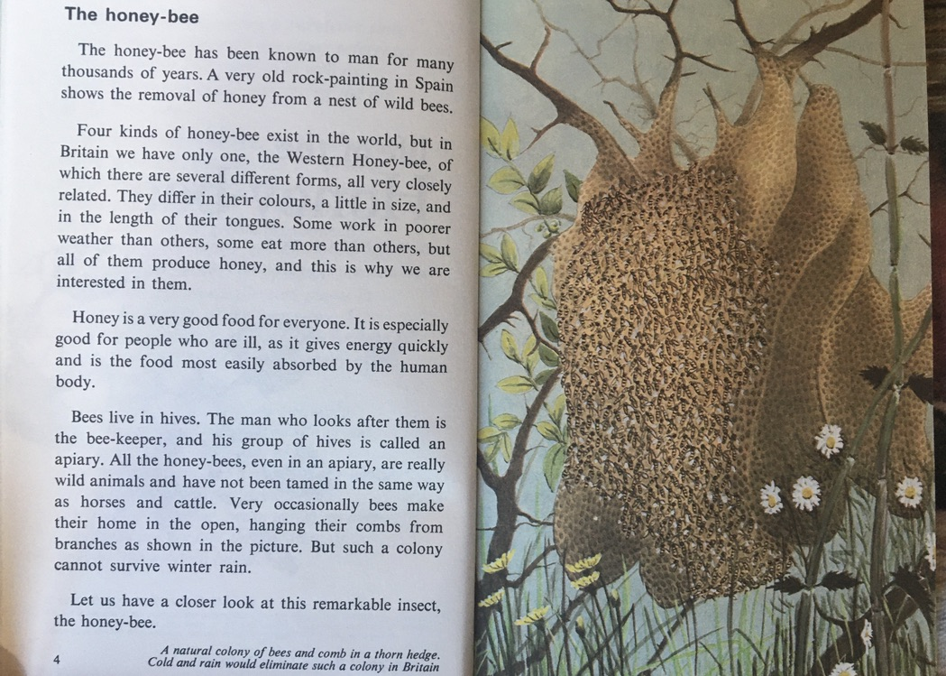
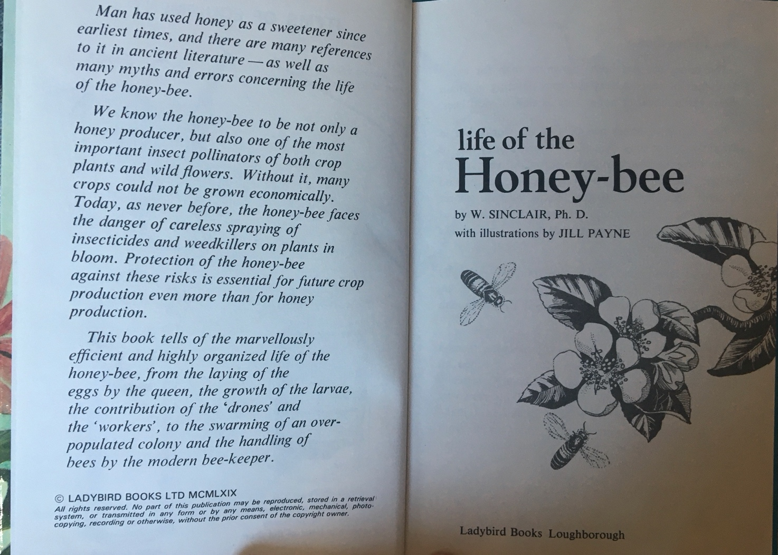
Comprehension Questions

- List three ways that the different forms of Western Honey-Bee may differ from one another?

- What ingredient does honey contain which gives people who eat it lots of energy quickly?

- What are the differences between tamed and untamed animals? Can you give an example of an animal that is tamed and one that is not?

- Why do you think certain colonies cannot survive rain?

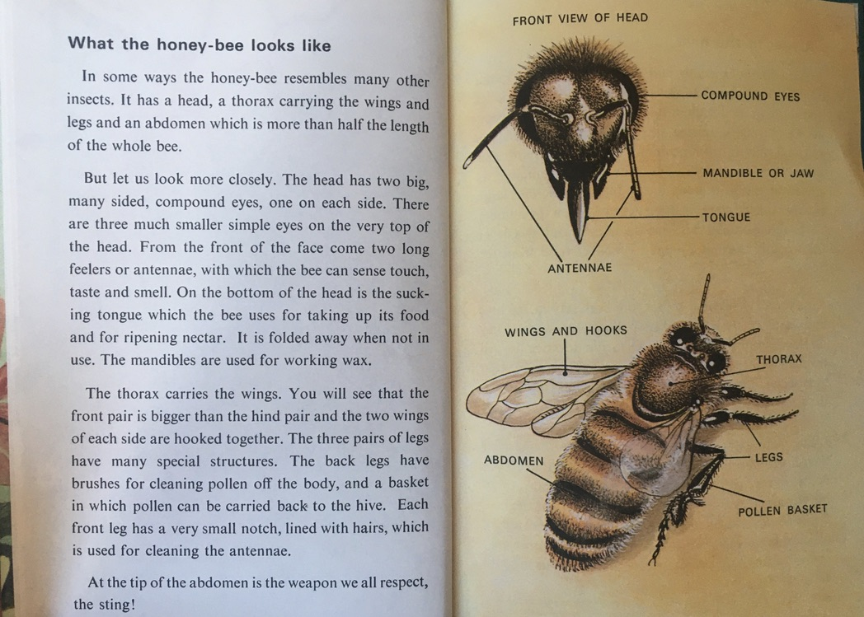
Comprehension Questions

- What three senses do bee’s feelers or antennae sense? What are the other two senses?

Challenge questions!

- The back legs of a bee has brushes which clean pollen off the body. What is the process called when bees (and other insects) disperse pollen in different areas like this?

- What could you do to help a honey-bee that looks as though they are struggling to stay alive, or not flying away? How could you save it? Have a look in your garden/porch/balcony (or any outdoor space you might have!) for any honey-bees who might need your help!

Good luck!

