Websites and Apps
Phonics Hero- Free for every child for 30 days.
https://www.phonicshero.com/coronavirus-support/
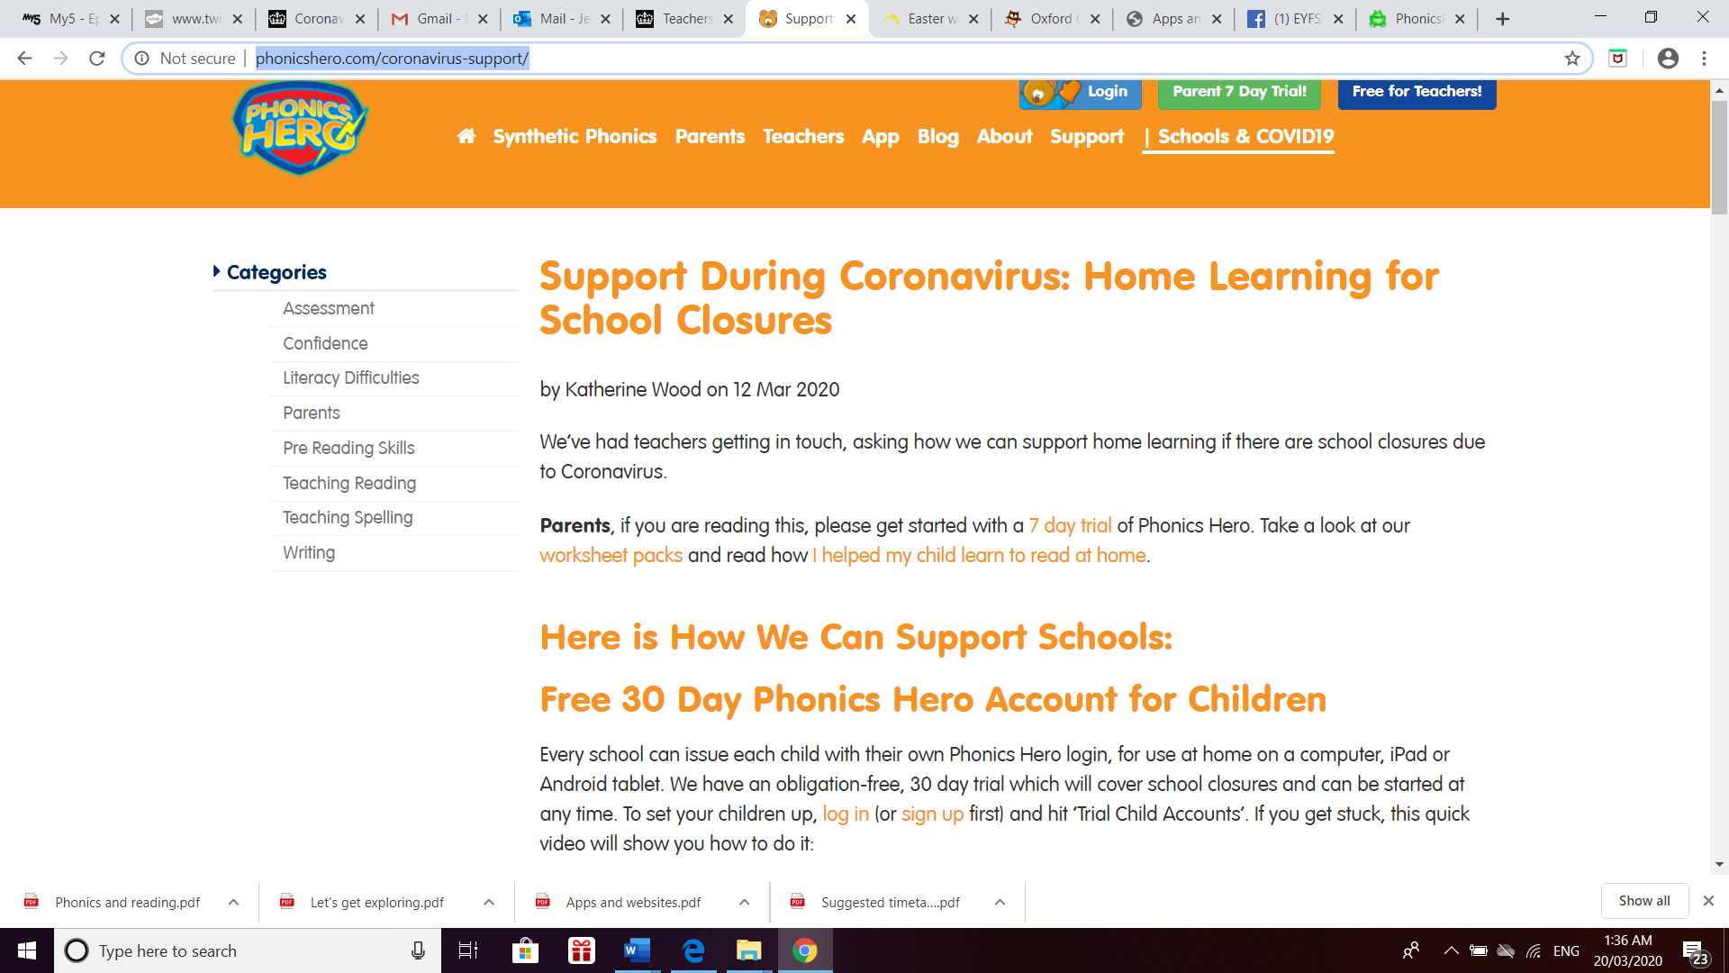
Phonics Play
https://www.phonicsplay.co.uk/
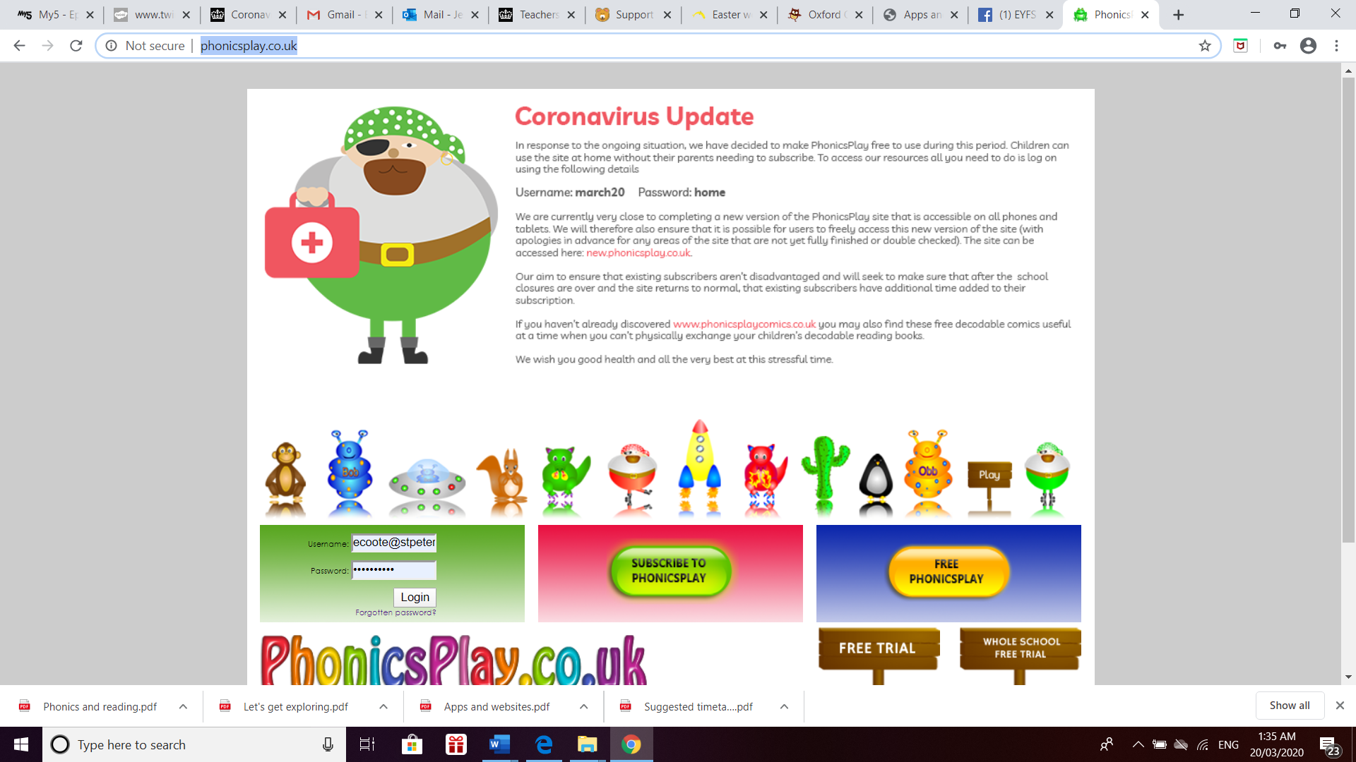

Books and read aloud- This good and it has activities to go with each book which are free!
https://classroommagazines.scholastic.com/support/learnathome.html?fbclid=IwAR3TwVDamh9XIlVzeU-au_GM-GXGD9t6WVY9Tk_bCR-YnHtn9WwczQyYMfY
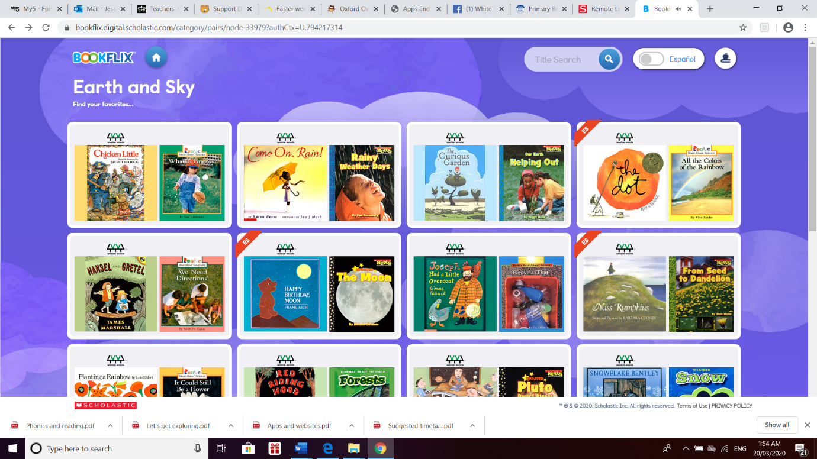

The muddy puddle
https://themuddypuddleteacher.co.uk/

Oxford Owl
https://www.oxfordowl.co.uk/for-home/

Phonics nest
https://thephonicsnest.co.uk/phonics-and-writing/

Early learn
https://auth.earlylearn.co.uk/

Maths
White Rose
https://whiterosemaths.com/homelearning/year-1/

