St Peter’s Year 5 Group Overview
 | Autumn 1 | Autumn 2 | Spring 1 | Spring 2 | Summer 1 | Summer 2
English | 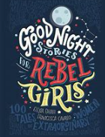  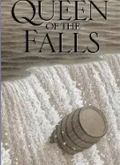  Queen of the Falls by Chris Van Allsburg, Good Night Stories for Rebel Girls by Elena Favilli and Francesca Cavallo  Outcome  Recount: write a series of diary entries  Curriculum links Geography – region in North America | 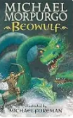  Beowulf by Michael Morpurgo  Outcome  Fiction: write a further adventure  Curriculum links  History – Viking and Anglo-Saxon struggle | 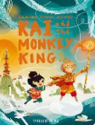  Kai and the Monkey King by Joe Todd-Stanton  Outcome  Fiction: write a myth  Curriculum links  History – Earliest civilisations (Shang Dynasty | 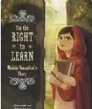  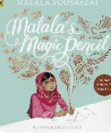  Malala’s Magic Pencil by Malala Yousafzai, For the Right to Learn by Rebecca Langston George  Outcome  Recount: write an autobiography  Curriculum links SMSC – Refugees | 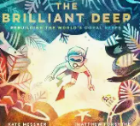  .  The Brilliant Deep by Kate Messner, Coral Reefs by Jason Chin  Outcome Persuasion/information: write an information leaflet  Curriculum links Geography/science – protecting the environment | 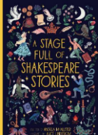  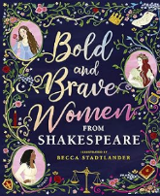  Bold and Brave Women from Shakespeare by Shakespeare Birthplace Trust, A Stage Full of Shakespeare Stories by Angela McAllister  Outcome  Recount: write and perform a soliloquy  Curriculum links Speaking and listening focus – Shakespeare
Poetry | 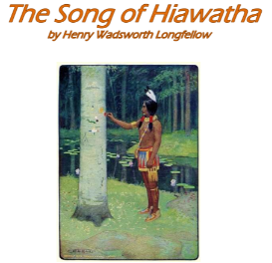 | 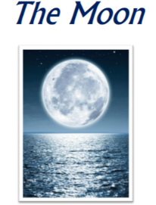 | 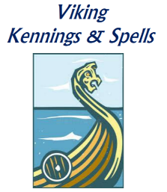 | 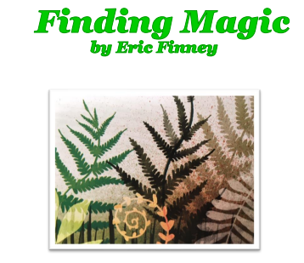 | 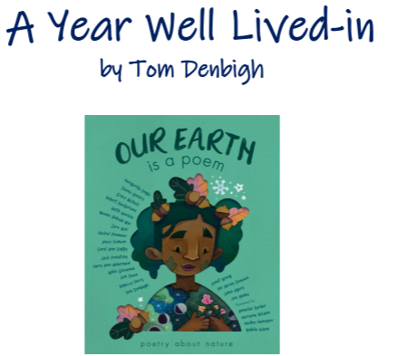 | 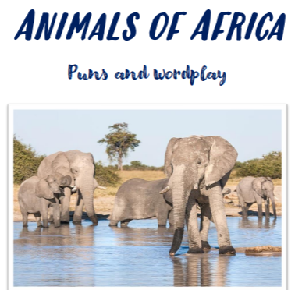
Maths | - Place value  - Addition and subtraction  - Multiplication and division A | - Multiplication and division A  - Fractions A | - Multiplication and division B  - Fractions B  - Decimals and percentages | - Decimals and percentages  - Perimeter and area  - Statistics | - Shape  - Position and direction  - Decimals | - Decimals  Negative numbers  Converting units
Science | Materials: Mixtures and separation | Materials: Properties and changes | Forces and space: Earth and space | Living Things: Life cycles and reproduction | Forces and space: Unbalanced forces | Making Connections: Human timeline and asteroids
RE | What do the miracles tell us about Jesus? | How do art and music convey Christmas? | How did the first five Sikh Gurus shape Sikhism? | What happens in church at Easter? | What does it mean to be a Sikh? | Understanding faith in….
Computing | Computing systems and networks – Sharing information | Creating media – Video editing | Programming A – Selection in physical computing | Data and information – Flat-file databases | Creating media – Vector drawing | Programming B – Selection in quizzes
Geography/  History | Geography: Mixtures and separation | History: Children in Victorian  Britain | History: Ancient Greeks |  | Geography: Why do oceans matter? | Geography: Why does population change?
Spanish | Que tiempo hace?  (What’s the weather like?) | La familia  (Family) | La cafetería  (Breakfast in the café) | Mi casa  (My house) | Los olimpiadas  (The Olympics) | Hábitats  (Habitats)
PSHE | Family and Relationships  Health and Wellbeing |  | Citizenship  Economic Wellbeing |  | Safety and the changing body  Transitions
PE | Swimming  Tennis | Swimming  Football/Netball | Swimming  Hockey | Swimming  Tag Rugby | Rounders  Dodgeball | Athletics
Music | Ongoing skills Unit C:  Music literacy, song and Ukulele performance
Music | ‘Cyclic patterns’ |  | ‘Cyclic patterns’ |  | ‘Cyclic patterns’
Art/DT | Art  Painting and Mixed Media: Colour Splash | DT  Mechanisms: Making a pop-up story book | Art  Painting and mixed media portraits | DT  Food: What could be healthier? | Art  Architecture | DT  Digital: monitoring devices

